DIFFERENT TYPES OF WINDOWS

1. Main Window is used to continuous output, the content of the main can be display of multiple pages.

2. Secondary window is use when the max. number is rows are fix and that all can be display on single page, it's not continuing.

3. Final Window is process at the end of the form processing, no matter if we are displaying the final window at the starting of first page, file system will complete the entire form processing the print the data inside of final window.

4. Copies window is used to mark the pages as original, duplicate copy, etc.

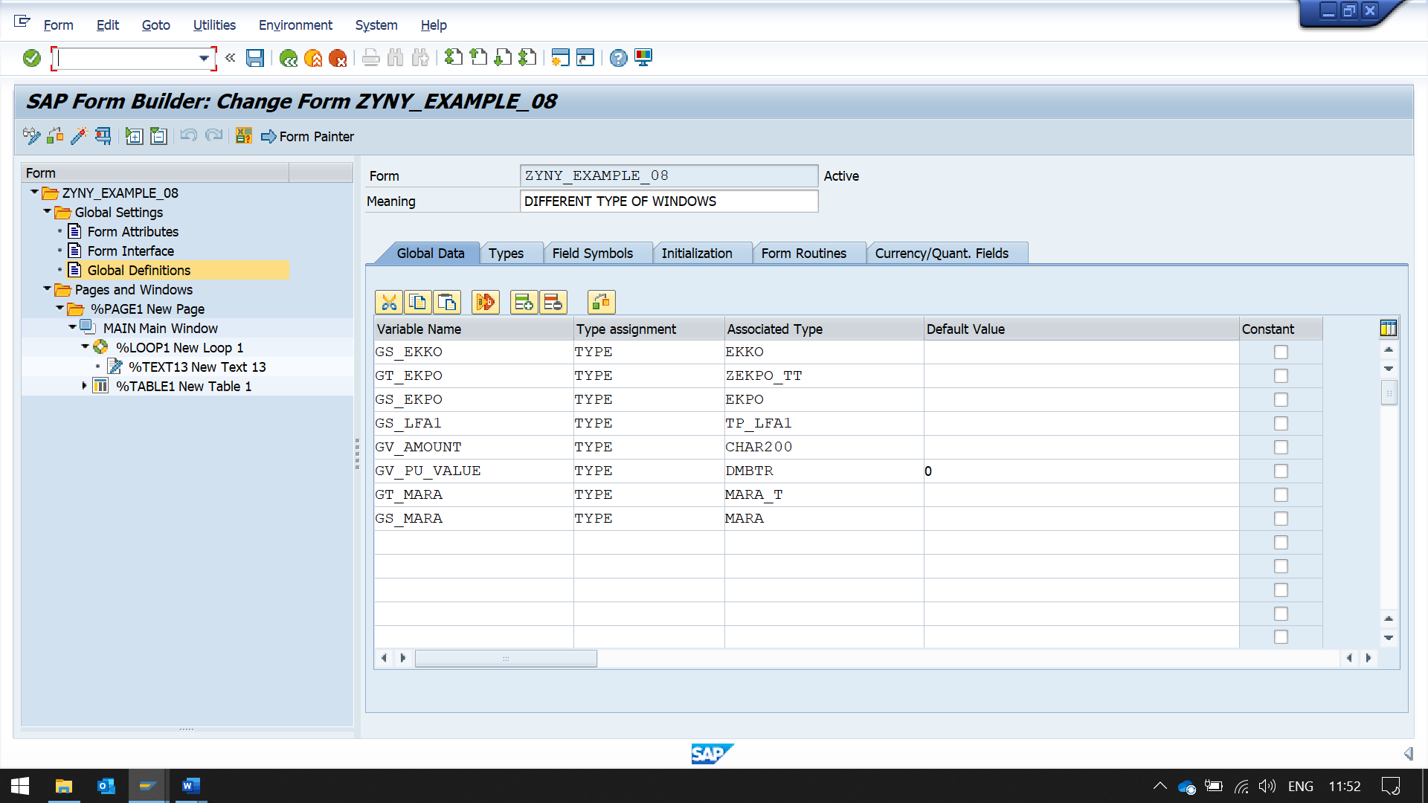

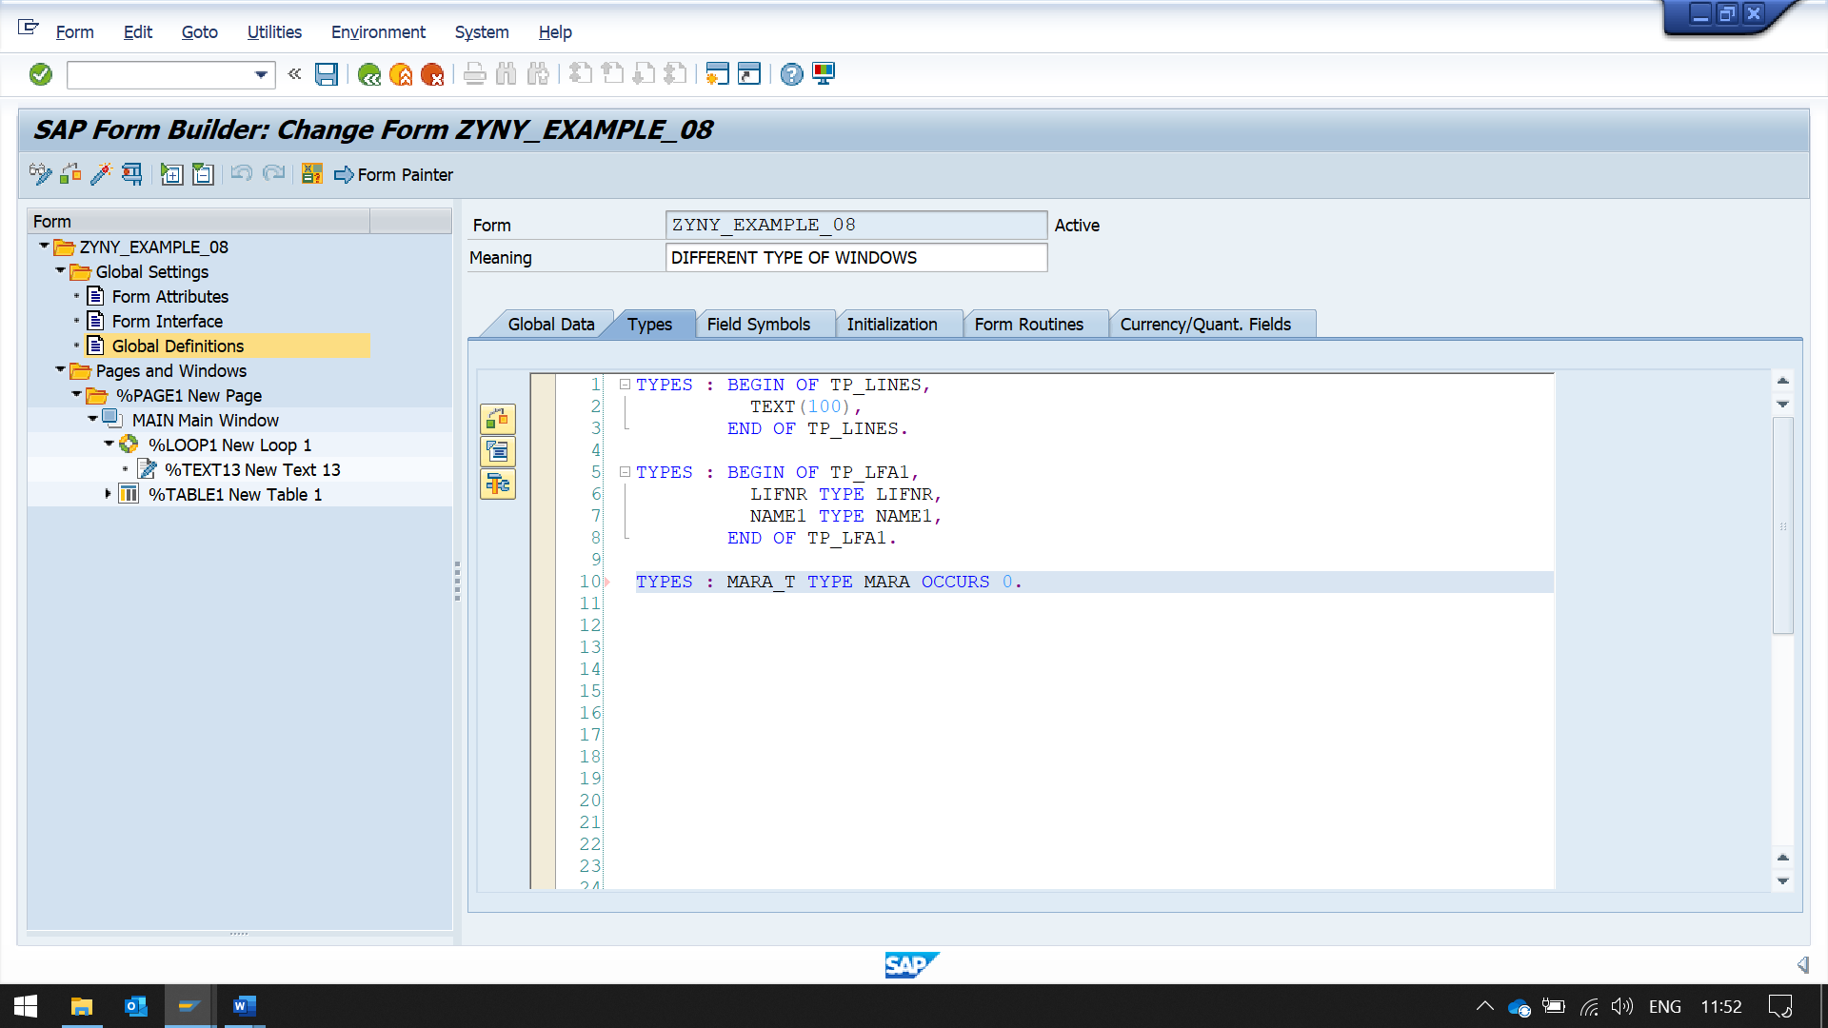

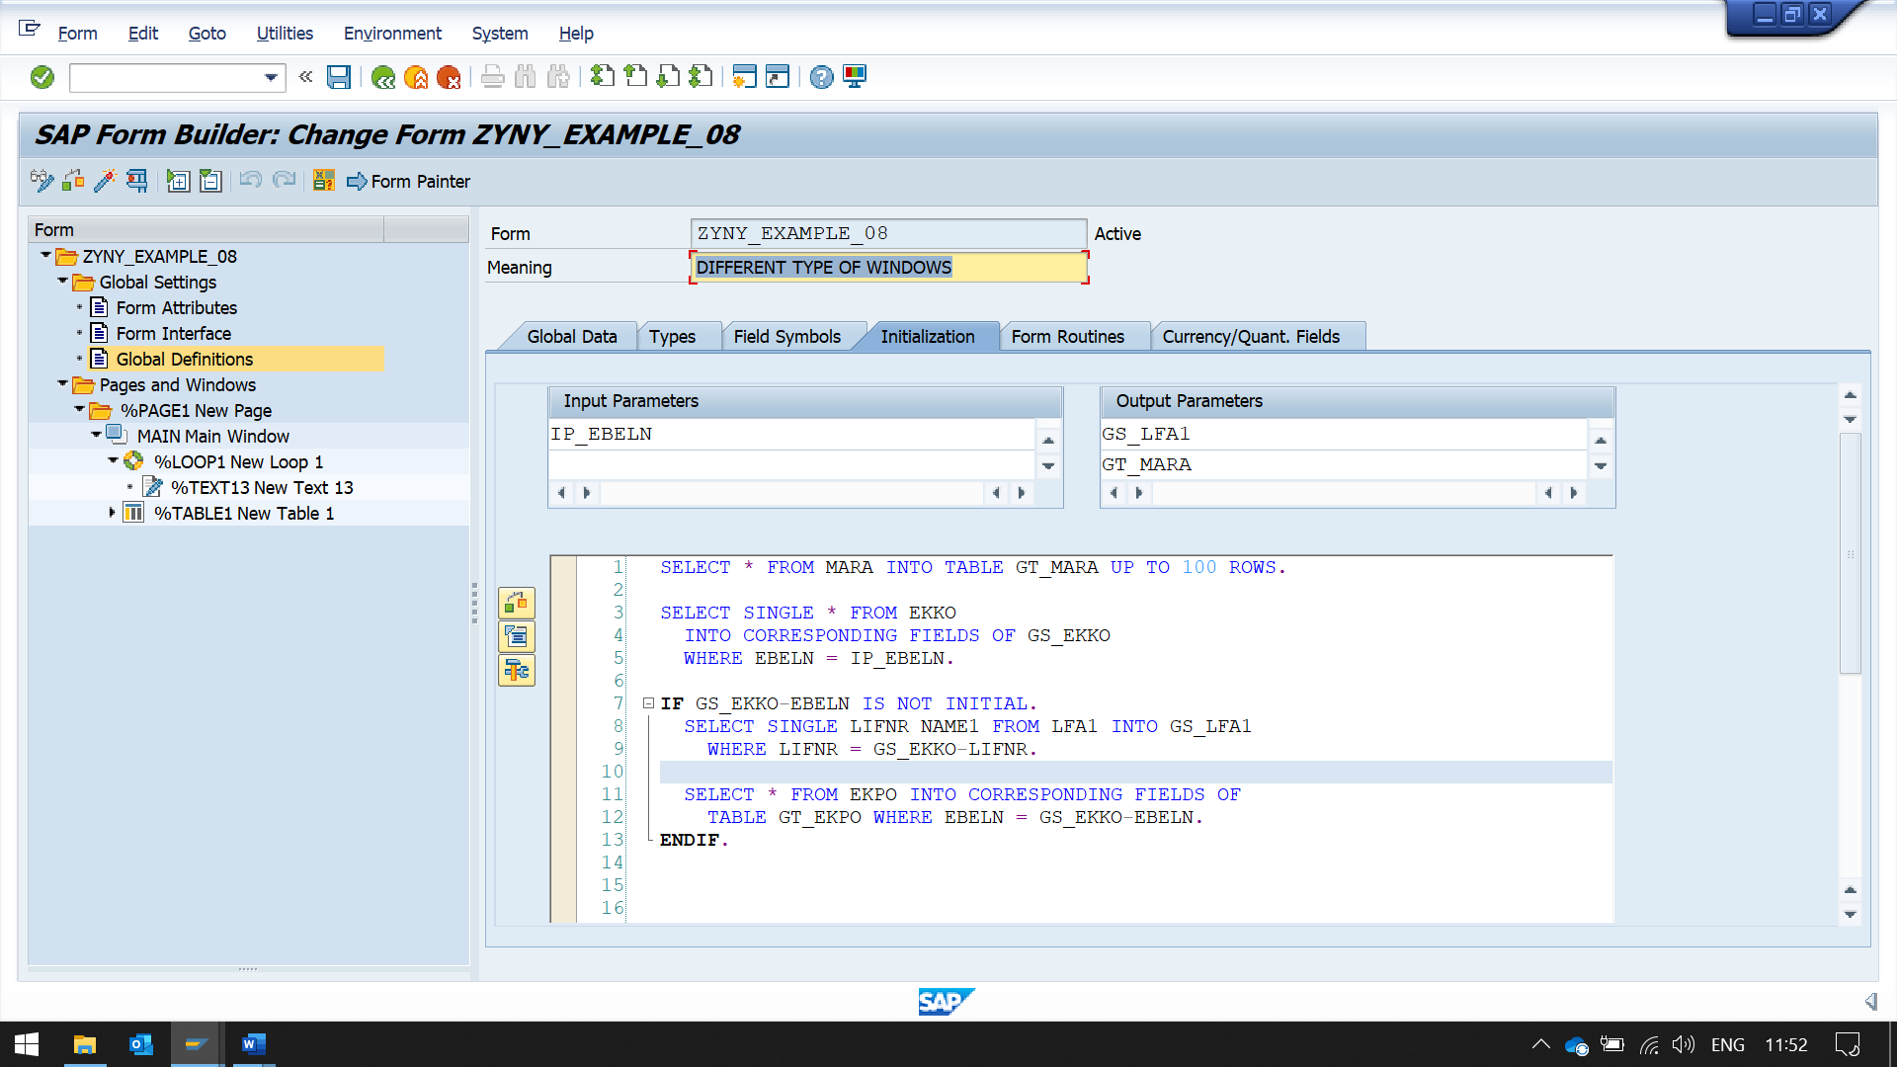

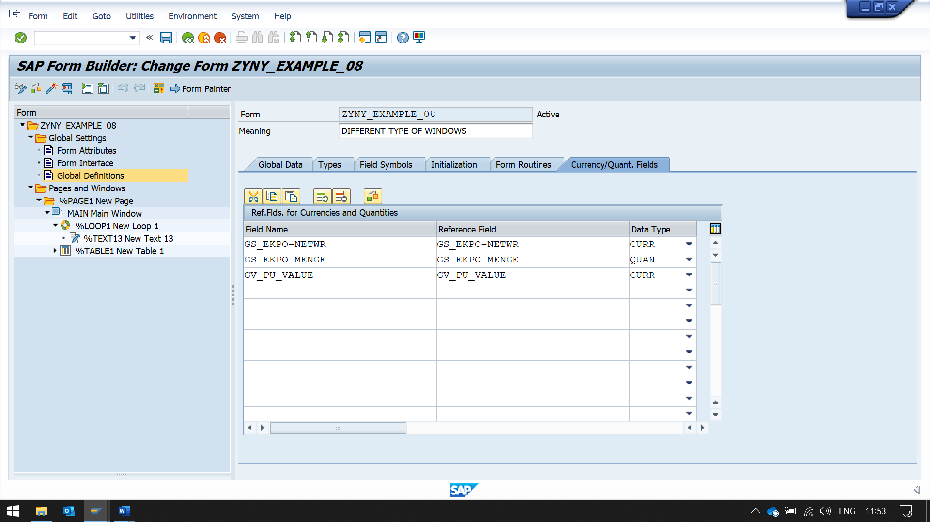

here we are using main window

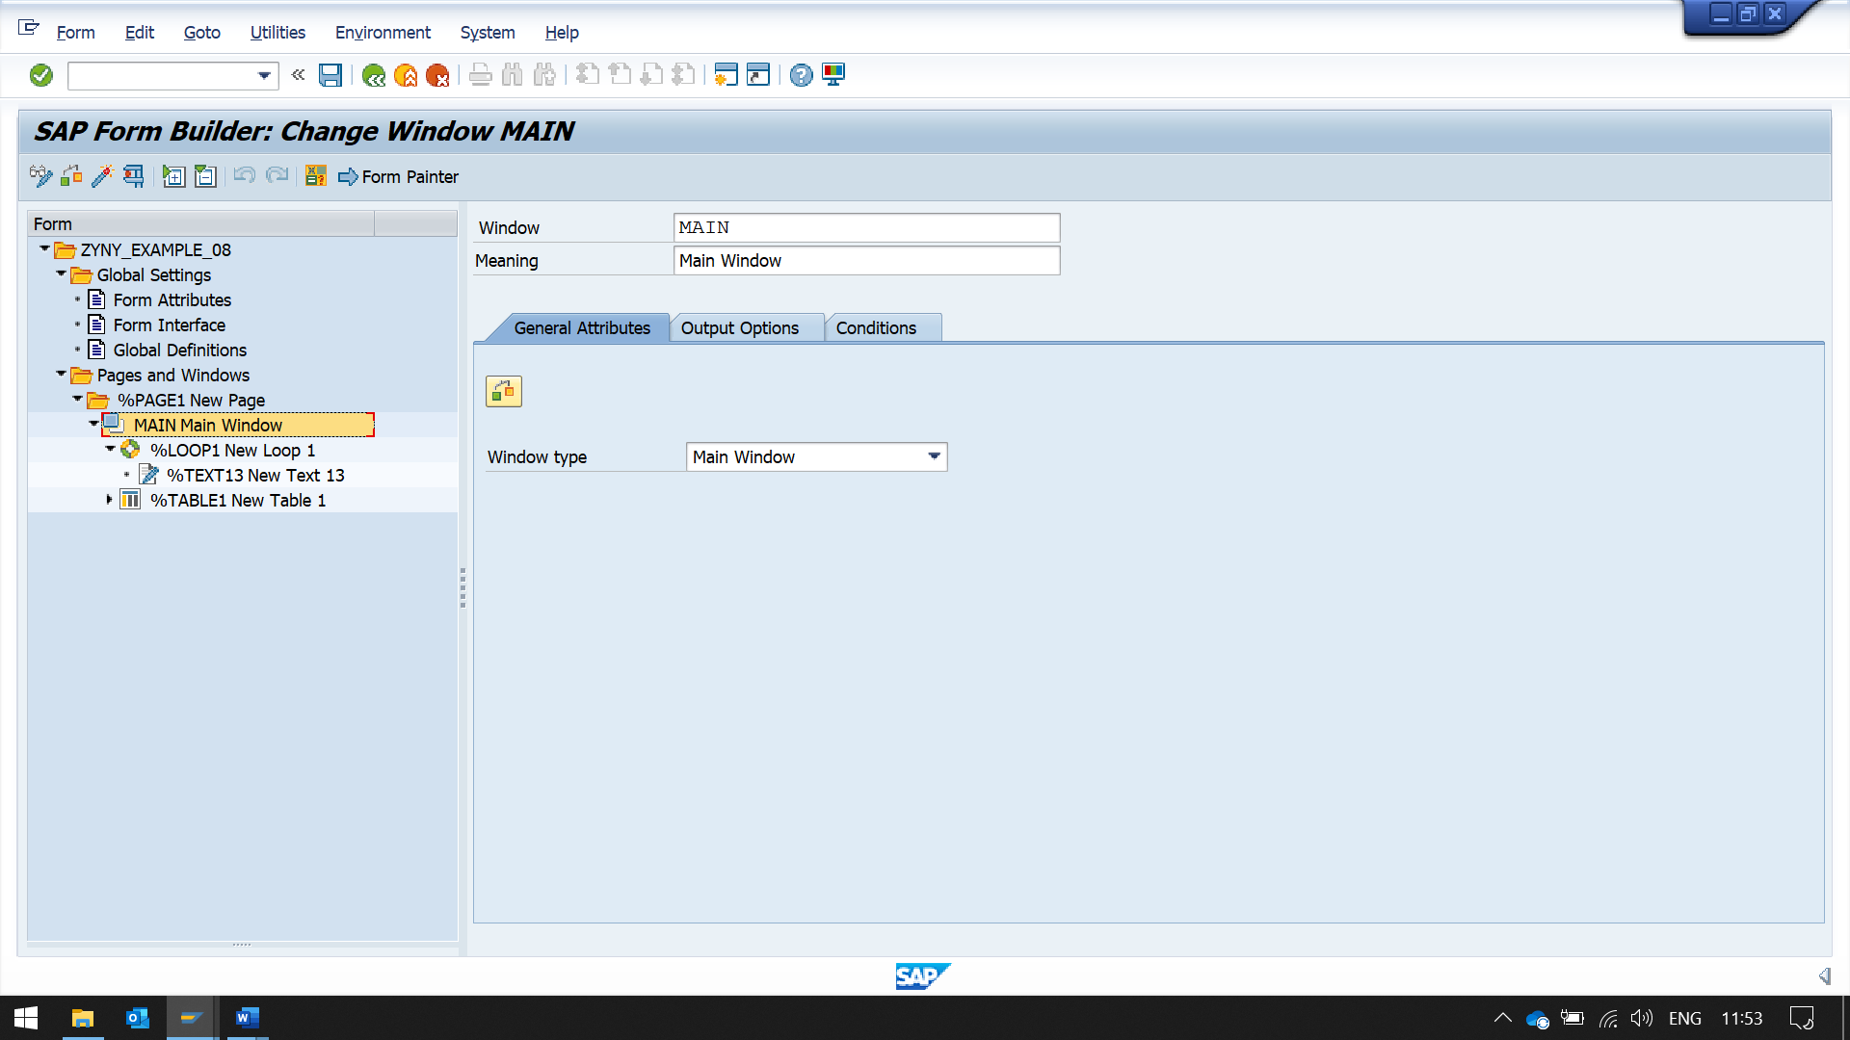

now printing data using loop and table

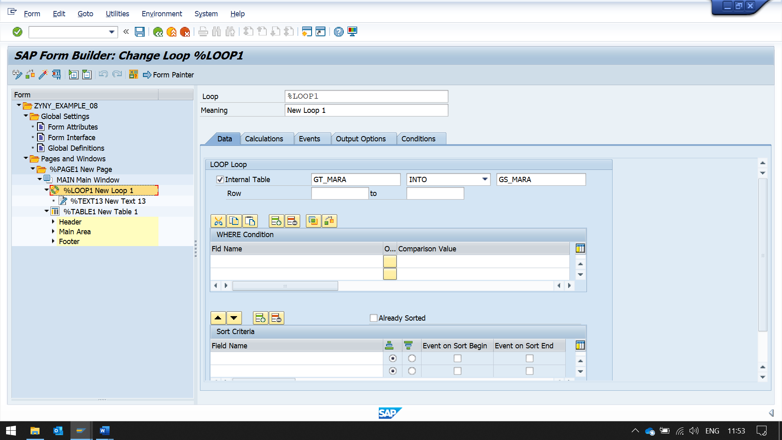

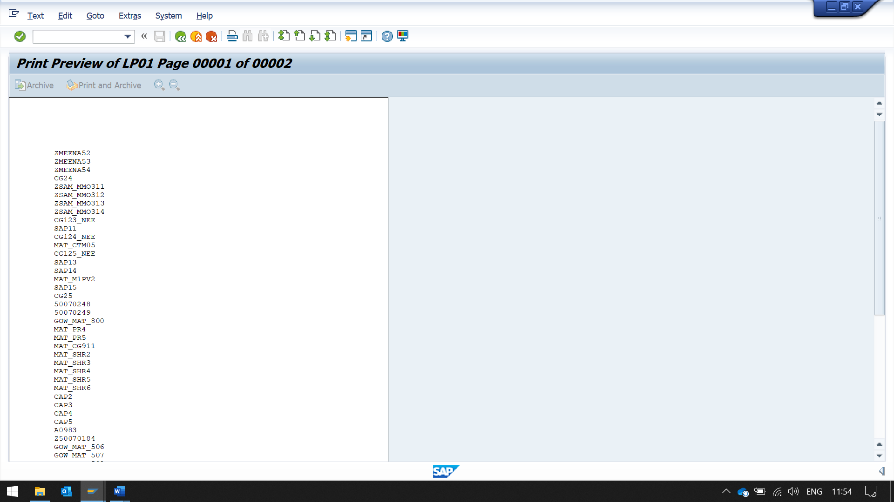

as you can see main window is continuing to next page automatically

now we are using secondary window instead of main window

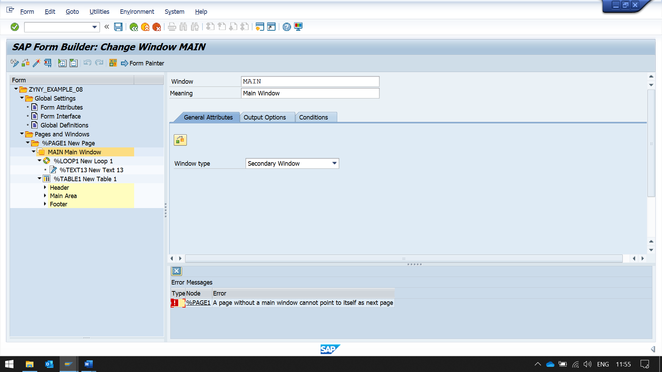

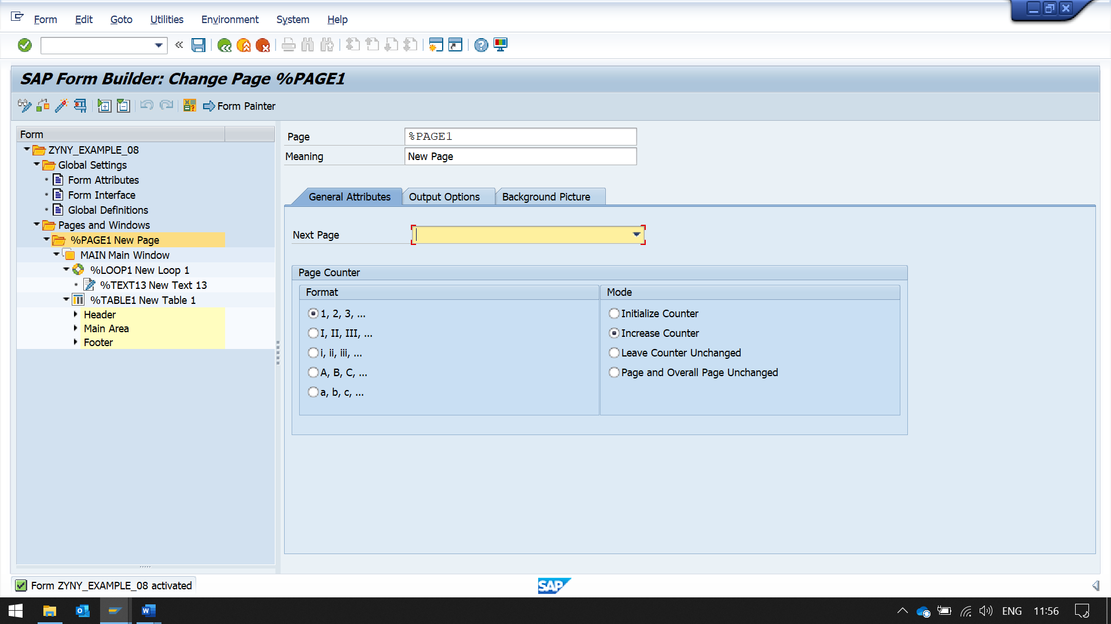

now it is only print one page

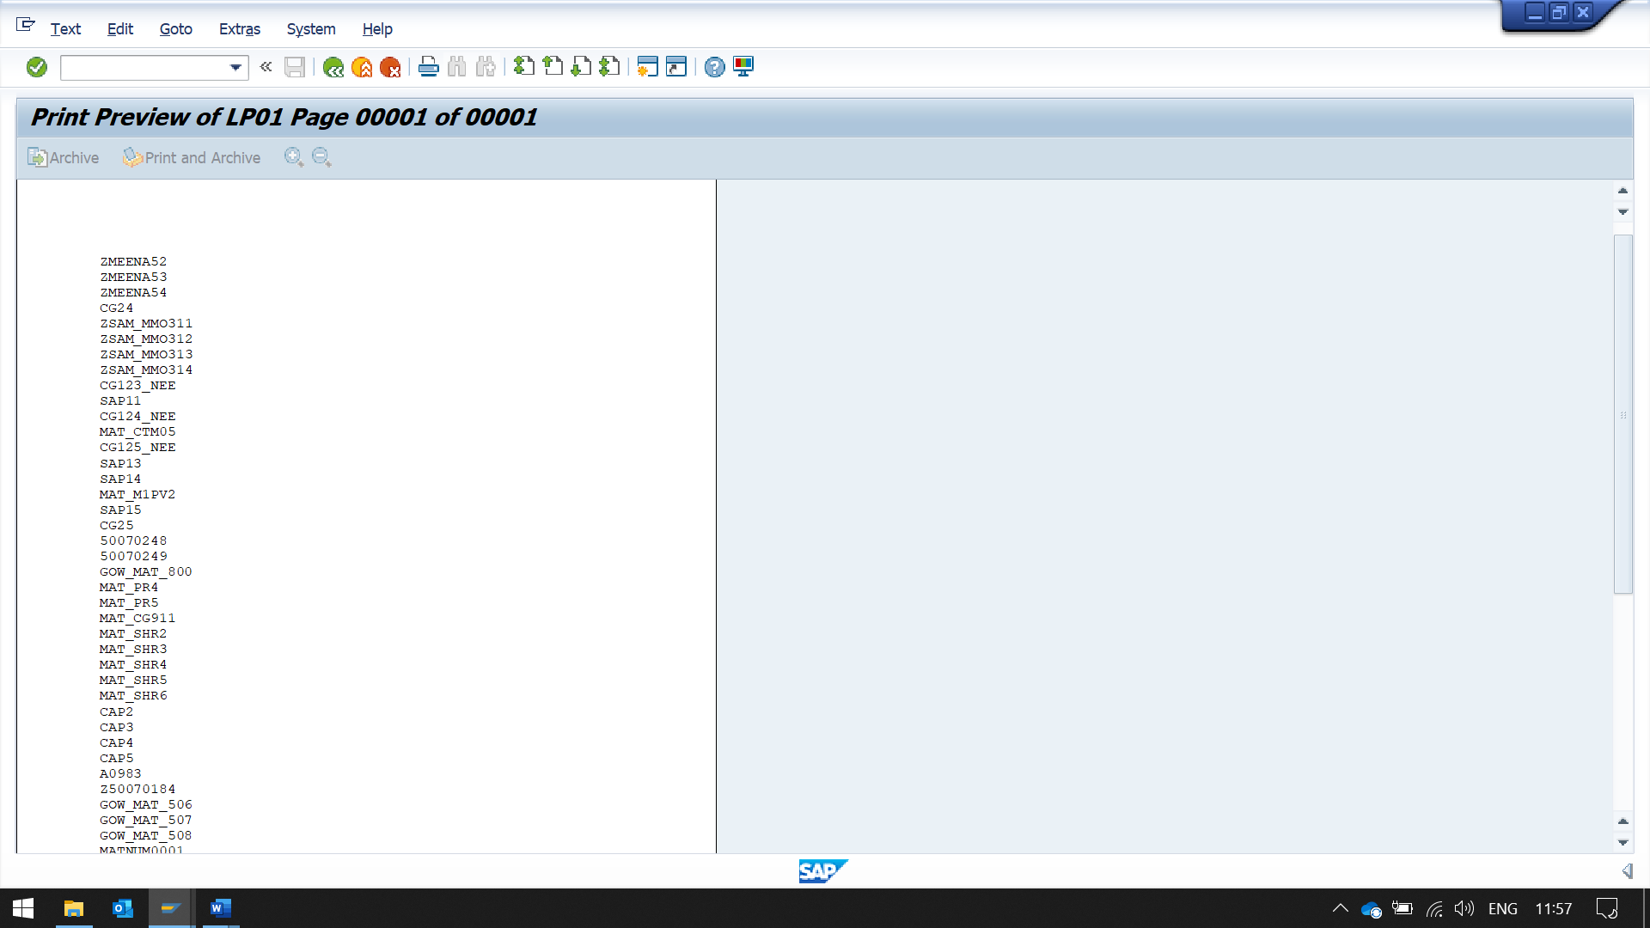

FINAL WINDOW

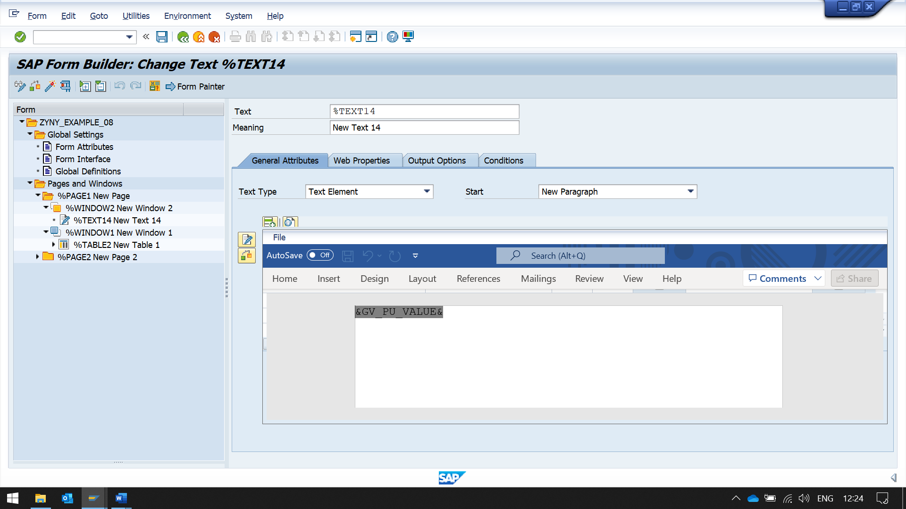HERE VALUE IS PRINTED FIRST, THEN TABLE IS PRINTED

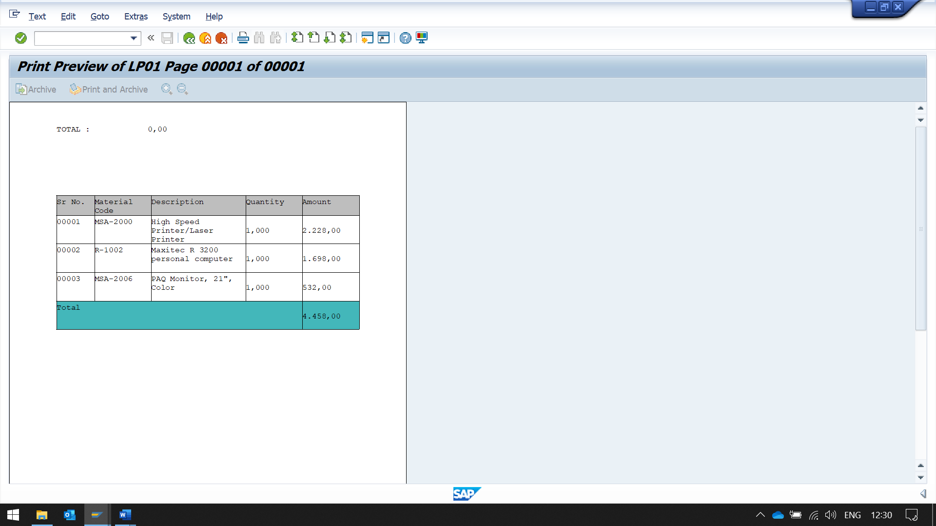

BUT THE VALUE OF TOTAL AT TOP IS 0

SINCE IT WAS EXECUTED FIRST TOTAL WAS NOT CALCULATED

NOW CHANGING WINDOW TYPE FROM SECONDARY WINDOW TO FINAL WINDOW

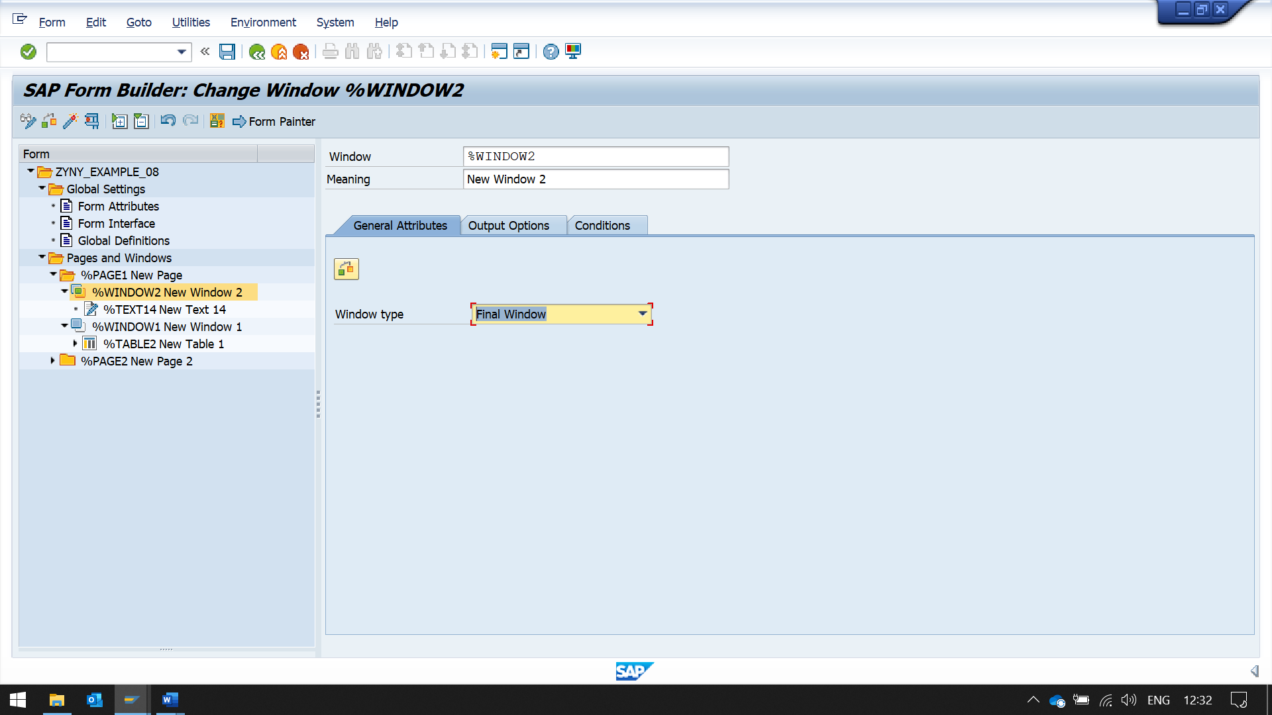

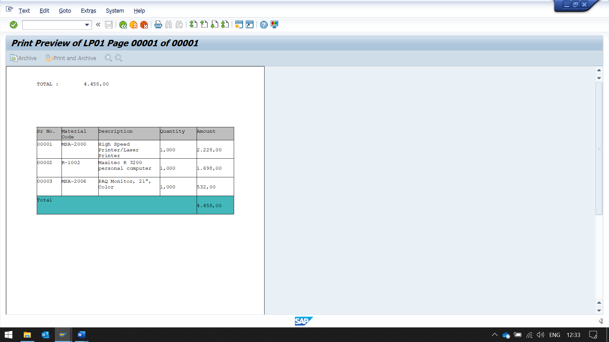

NOW SENCOND WINDOW IS PRINTED LAST, AT THAT TIME TOTAL WAS CALCULATED AND PRINTED

COPY SCREEN

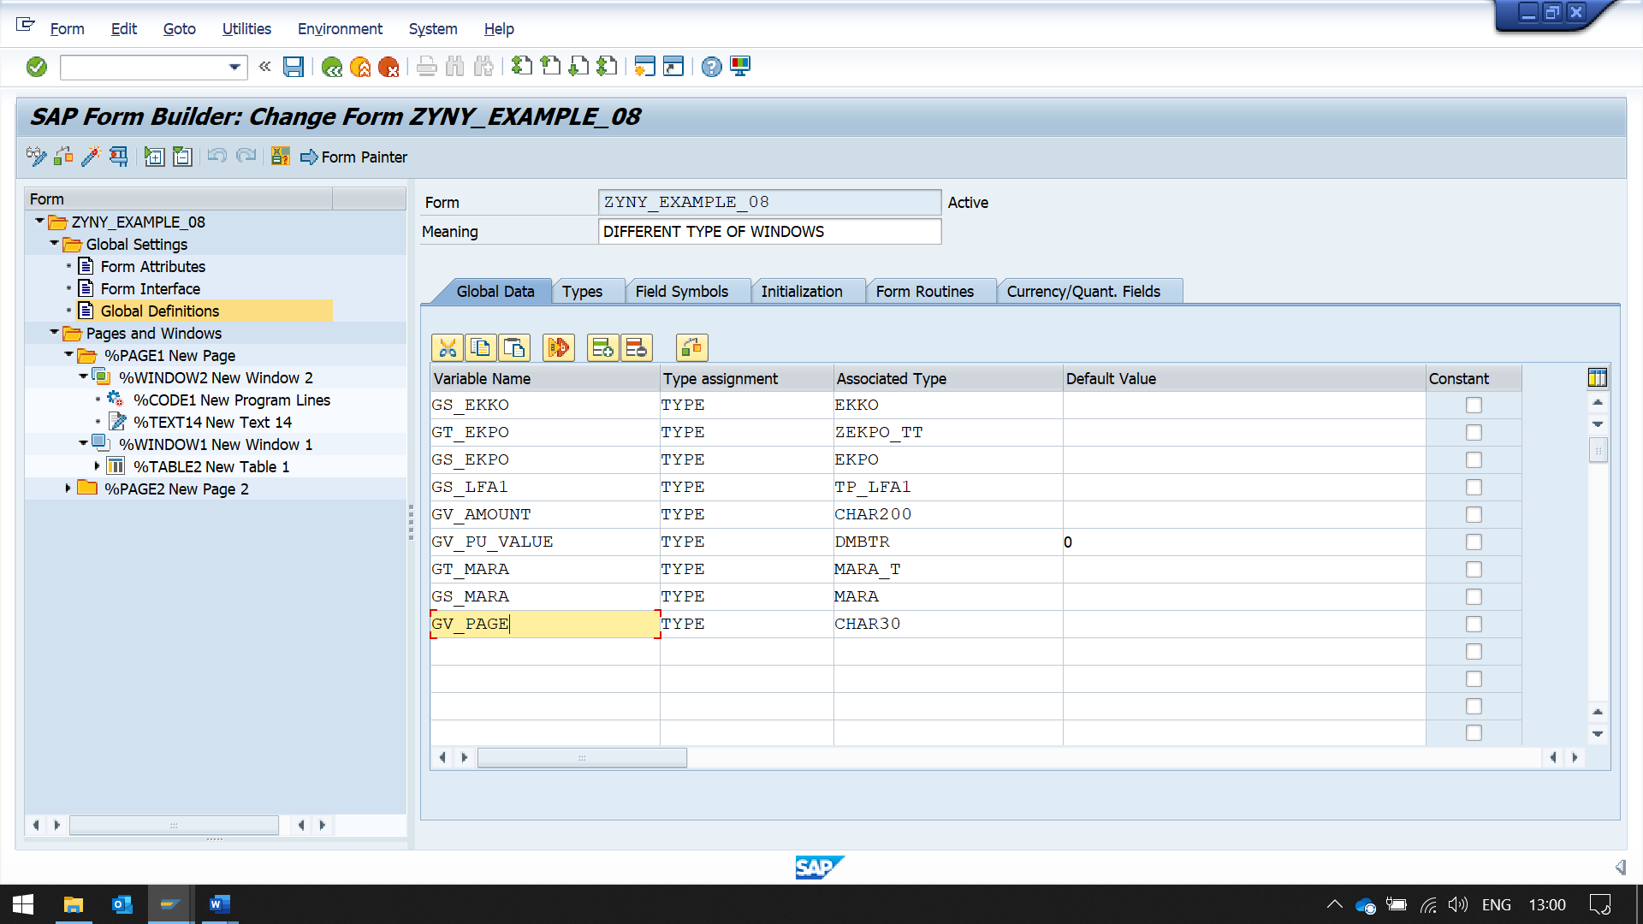

NOW CHANGING WINDOW TYPE FROM SECONDARY WINDOW TO COPIES WINDOW

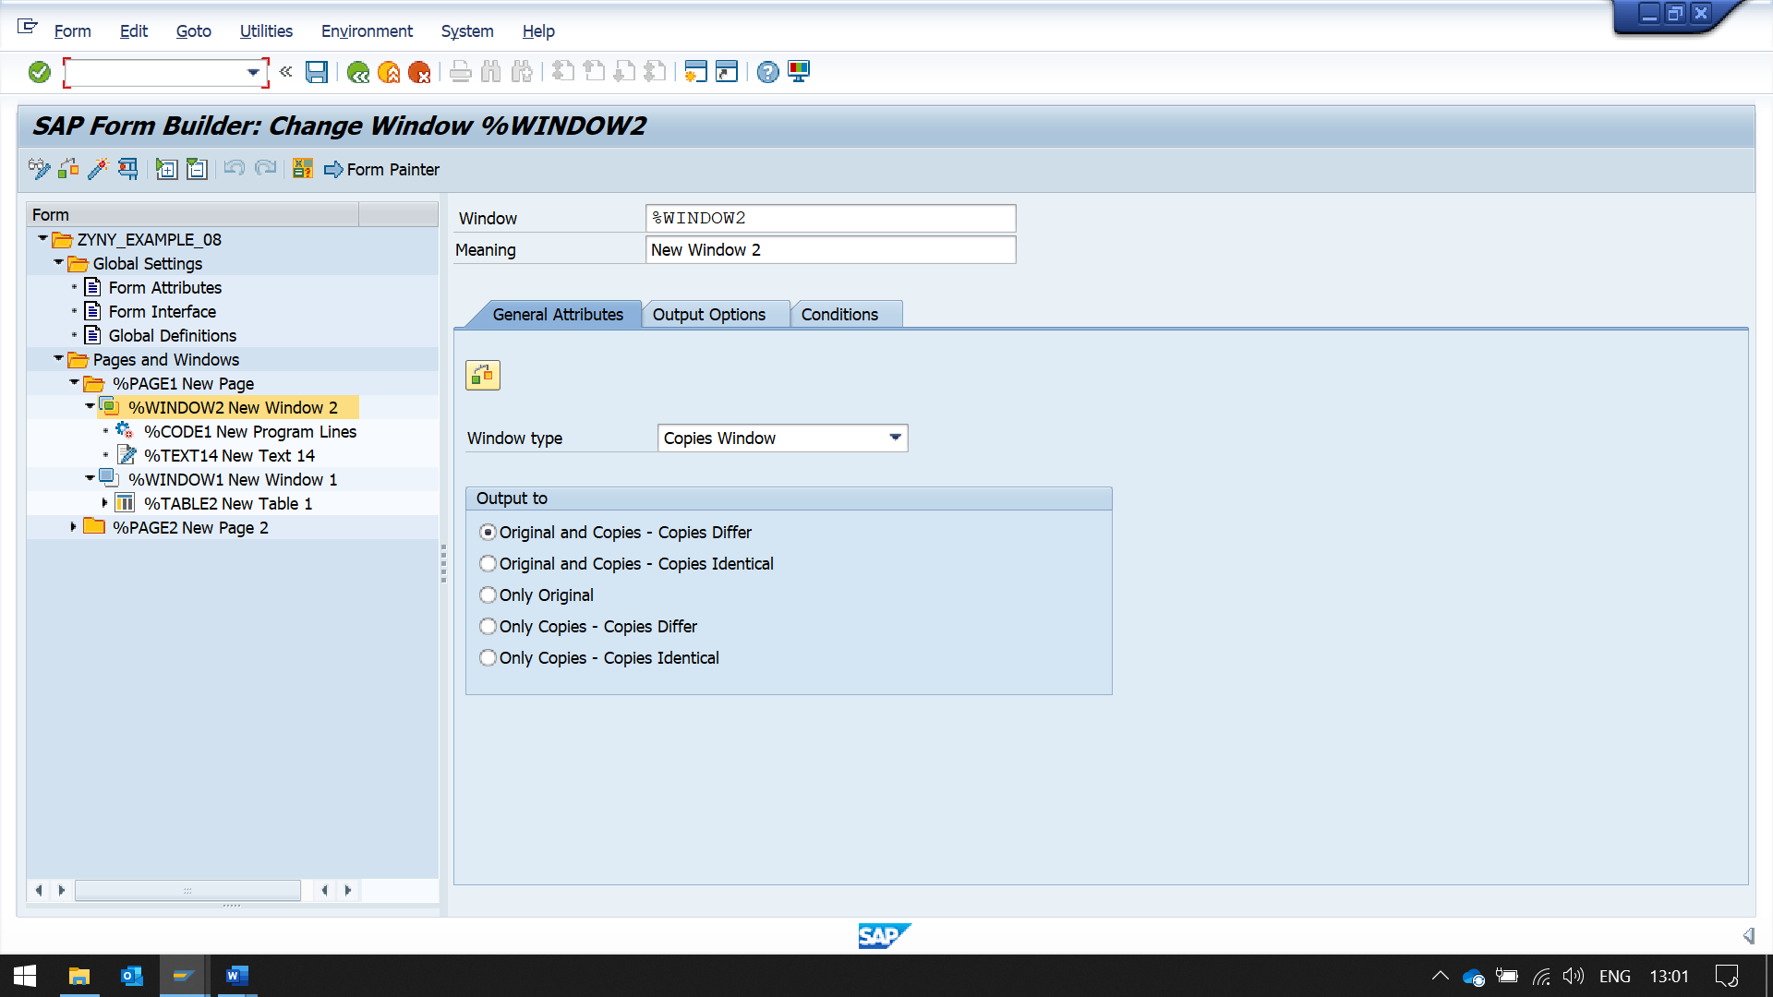

NOW CREATE A PROGRAM LINE IN THIS WINDOW

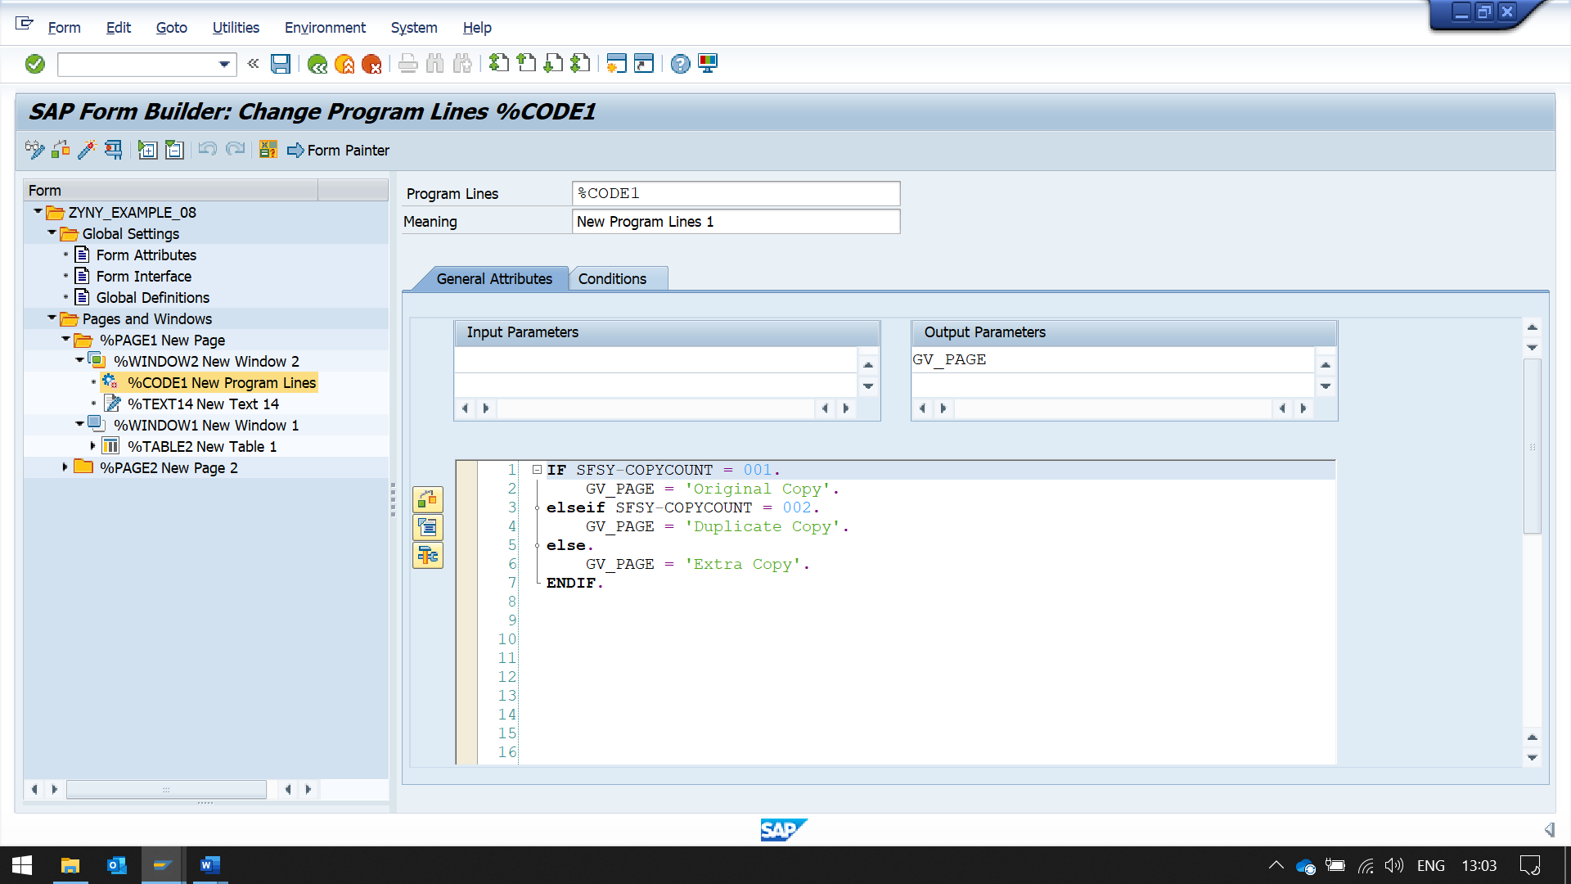

NOW ADDING TEXT IN THIS WINDOW

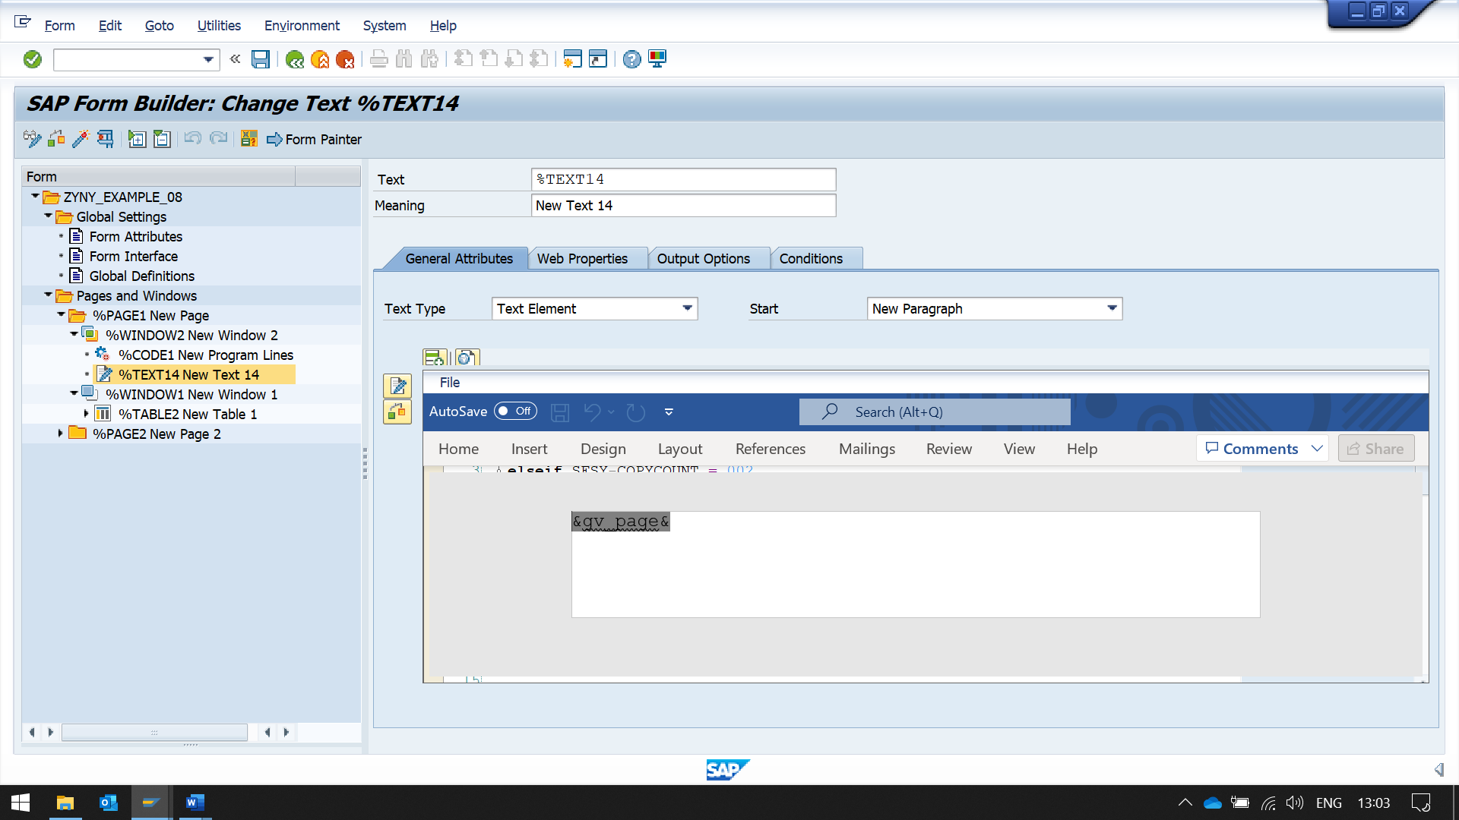

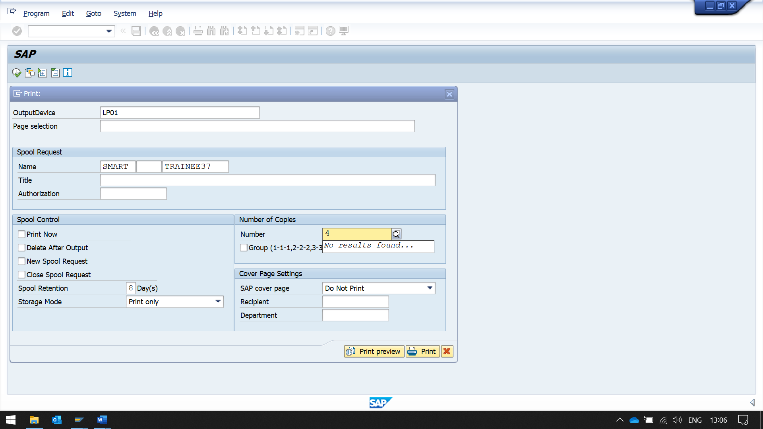 HERE ENTER THE NUMBER OF COPIES 